
J Open http://dx.doi.org/10.70728/z2y0g1388


ARTICLE

Preparation of Articles for J Open (2025)

A. Author1,2, B. Author2,* and C. Author2
¹ School of A, University of A, Spokane 20237, USA
² School of B, University of B, Spokane 02139, USA

Abstract
A single paragraph of about 200 words maximum. For research articles, abstracts should give a pertinent overview of the work. We strongly encourage authors to use the following style of structured abstracts, but without headings: (1) Background: place the question addressed in a broad context and highlight the purpose of the study; (2) Methods: describe briefly the main methods or treatments applied;
(3) Results: summarize the article’s main findings;
(4) Conclusions: indicate the main conclusions or interpretations. The abstract should be an objective representation of the article, it must not contain results which are not presented and substantiated in the main text and should not exaggerate the main conclusions.

Keywords: Keywords 1, keywords 2, keywords 3,
keywords 4, keywords 5.
Citation
Author, A., Author, B., & Author, C. (2025). Preparation of Articles for J Open (2025). J Open, 01(01), 1–4.

Copyright: © 2025 by the authors. Submitted to J Open for possible open access publication under the terms and conditions of the Creative Commons Attribution-NonCommercial (CC BY-NC) license (https://creativecommons.org/licenses/by/4.0/).

Submitted: submit-date Accepted: accept-date Published: pub-date
Vol. 01, No. 01, 2025.  10.70728/z2y0g1388
*Corresponding author:
B. Author
e-mail@e-mail.com

Introduction
The introduction should briefly place the study in a broad context and highlight why it is important. It should define the purpose of the work and its significance. The current state of the research field should be reviewed carefully and key publications cited. Please highlight controversial and diverging hypotheses when necessary. Finally, briefly mention the main aim of the work and highlight the principal conclusions. As far as possible, please keep the introduction comprehensible to scientists outside your particular field of research.
Cite a journal [1]. Now cite a book reference or other types of reference in this format [2].

Materials and Methods
Materials and Methods should be described with sufficient details to allow others to replicate and build on published results. Please note that publication of your manuscript implicates that you must make all materials, data, computer code, and protocols associated with the publication available to readers. Please disclose at the submission stage any restrictions on the availability of materials or information. New methods and protocols should be described in detail while well-established methods can be briefly described and appropriately cited.
Research manuscripts reporting large datasets that are deposited in a publicly avail-able database should specify where the data have been deposited and provide the relevant accession numbers [3]. If the accession numbers have not yet been obtained at the time of submission, please state that they will be provided during review. They must be provided prior to publication.
Interventionary studies involving animals or humans, and other studies require ethical approval must list the authority that provided approval and the corresponding ethical approval code.

This is an example of a quote.

Results
This section may be divided by subheadings. It should provide a concise and precise description of the experimental results, their interpretation as well as the experimental conclusions that can be drawn. Tab.
1. Figures as shown in Fig. 1.

Subsection
    - Subsubsection
Bulleted lists look like this:
      - First bullet;
      - Second bullet;
      - Third bullet.
Numbered lists can be added as follows:
- First item;
- Second item;
- Third item.
The text continues here.

Figures, Tables and Schemes
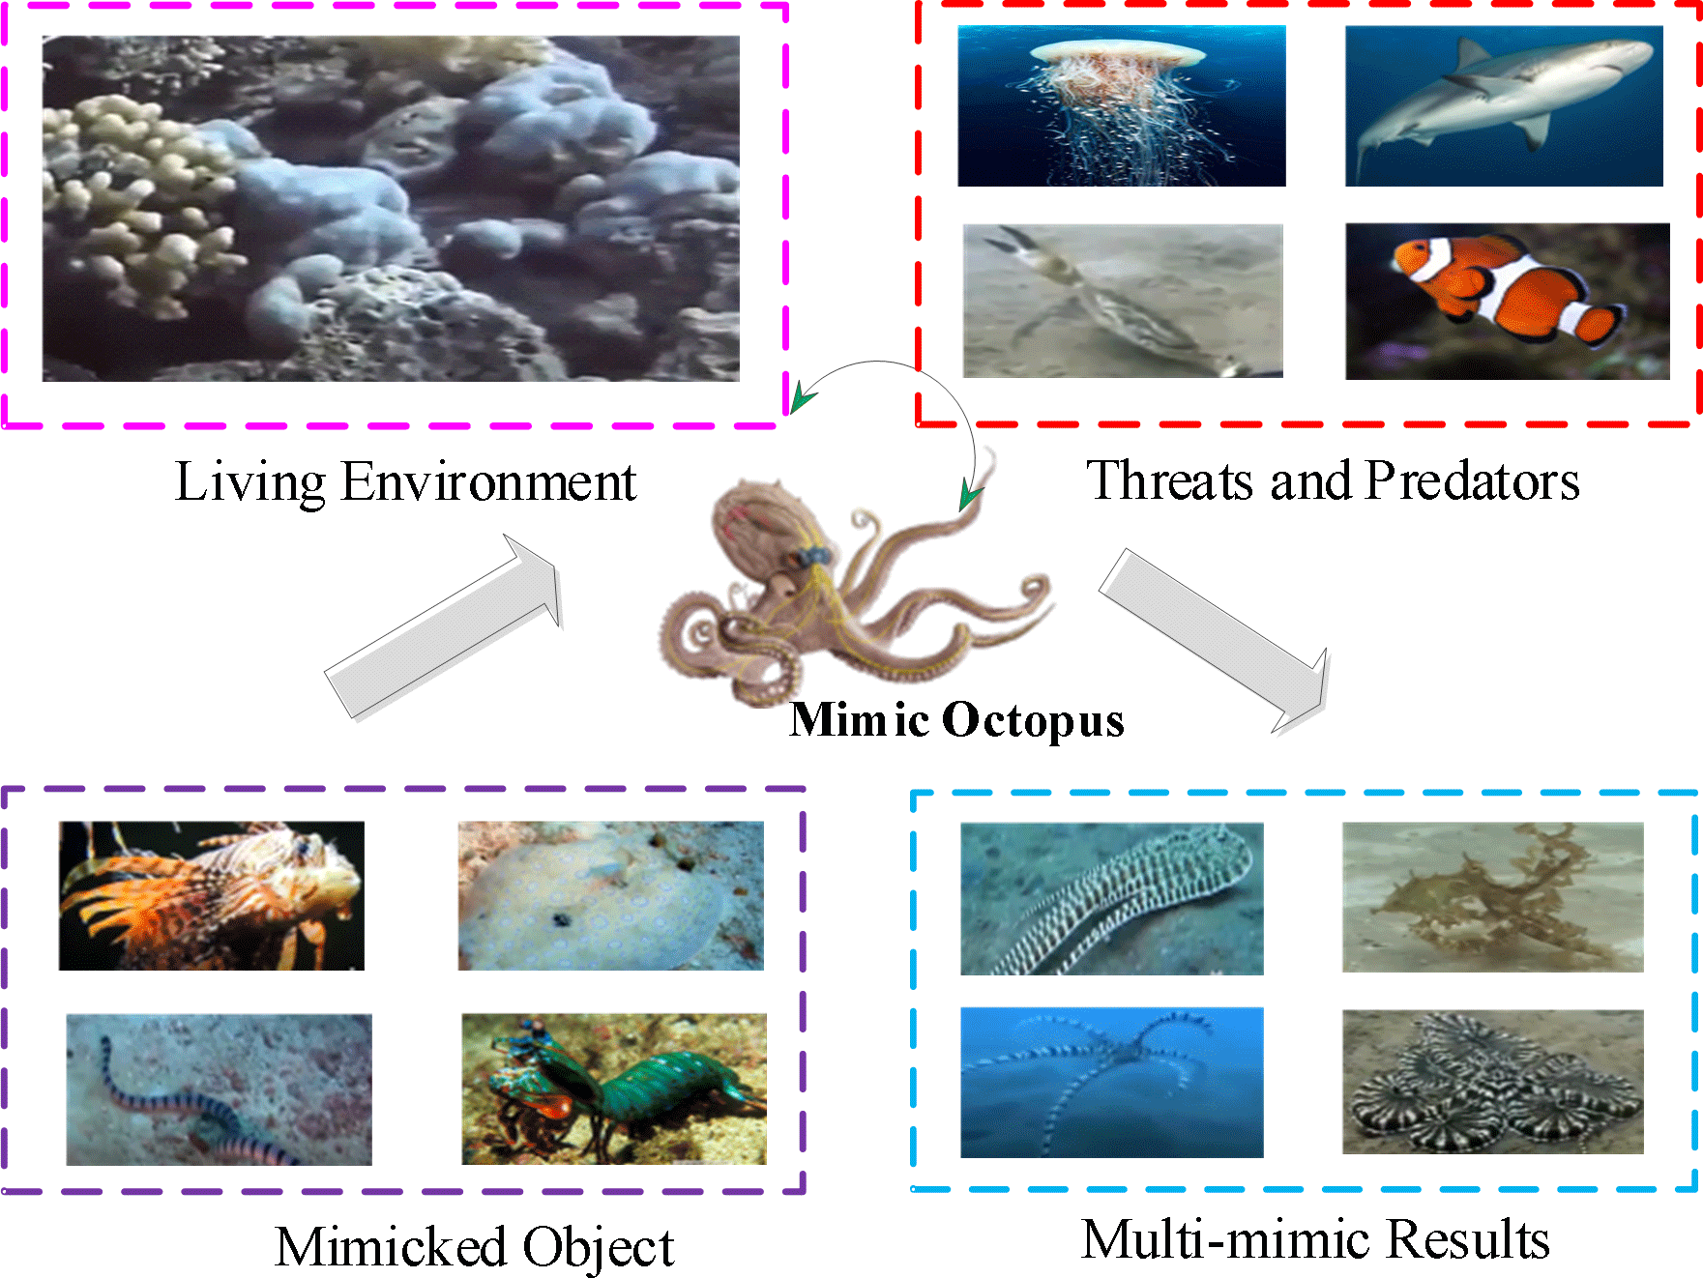
Figure 1. Mimic octopus.

Formatting of Mathematical Components
This is the example 1 of equation:
a = 1, (1)
the text following an equation need not be a new paragraph. Please punctuate equations as regular text.

Algorithm 1: How to write algorithms
Data: this text
Result: how to write algorithm with LATEX2e initialization;
while not at end of this document do
read current;
if understand then
go to next section;
current section becomes this one;

else
go back to the beginning of current section;

end end

Table 1. Forest fire classification table.

Classification | Overall Accuracy
0.98 | 0.98
0.98 | 0.98
0.98 | 0.98
0.98 | 0.98
0.98 | 0.98

Discussion
Authors should discuss the results and how they can be interpreted from the perspective of previous studies and of the working hypotheses. The findings and their implications should be discussed in the broadest context possible. Future research directions may also be highlighted.

Conclusions
This section is not mandatory, but can be added to the manuscript if the discussion is unusually long or complex.

Patents
This section is not mandatory, but may be added if there are patents resulting from the work reported in this manuscript.
Author Contributions: For research articles with several authors, a short paragraph specifying their individual contributions must be provided. The following statements should be used “Conceptualization, X.X. and Y.Y.; methodology, X.X.; software, X.X.; validation, X.X.,
Y.Y. and Z.Z.; formal analysis, X.X.; investigation, X.X.; resources, X.X.; data curation, X.X.; writing—original draft preparation, X.X.; writing—review and editing, X.X.; visualization, X.X.; supervision, X.X.; project administration, X.X.; funding acquisition, Y.Y. All authors have read and

agreed to the published version of the manuscript.”
Funding: Please add: “This research received no external funding” or “This research was funded by NAME OF FUNDER grant number XXX.” and and “The APC was funded by XXX”. Check carefully that the details given are accurate and use the standard spelling of funding agency names at https://search.crossref.org/funding, any errors may affect your future funding.
Institutional Review Board Statement: In this section, you should add the Institutional Review Board Statement and approval number, if relevant to your study. You might choose to exclude this statement if the study did not require ethical approval. Please note that the Editorial Office might ask you for further information. Please add “The study was conducted in accordance with the Declaration of Helsinki, and approved by the Institutional Review Board (or Ethics Committee) of NAME OF INSTITUTE (protocol code XXX and date of approval).” for studies involving humans. OR “The animal study protocol was approved by the Institutional Review Board (or Ethics Committee) of NAME OF INSTITUTE (protocol code XXX and date of approval).” for studies involving animals. OR “Ethical review and approval were waived for this study due to REASON (please provide a detailed justification).” OR “Not applicable” for studies not involving humans or animals.
Informed Consent Statement: Any research article describing a study involving humans should contain this statement. Please add “Informed consent was obtained from all subjects involved in the study.” OR “Patient consent was waived due to REASON (please provide a detailed justification).” OR “Not applicable” for studies not involving humans. You might also choose to exclude this statement if the study did not involve humans.
Written informed consent for publication must be obtained from participating patients who can be identified (including by the patients themselves). Please state “Written informed consent has been obtained from the patient(s) to publish this paper” if applicable.
Data Availability Statement: We encourage all authors of articles published in J Open journals to share their research data. In this section, please provide details regarding where data supporting reported results can be found, including links to publicly archived datasets analyzed or generated during the study. Where no new data were created, or where data is unavailable due to privacy or ethical restrictions, a statement is still required. Suggested Data Availability Statements are available in section “Privacy Policy” at https:
//biology-science.com/index.php/journal/about/privacy.
Acknowledgments: In this section you can acknowledge any support given which is not covered by the author contribution or funding sections. This may include administrative and technical support, or donations in kind (e.g., materials used for experiments).
Conflicts of Interest: Declare conflicts of interest or state “The authors declare no conflicts of interest.” Authors must
identify and declare any personal circumstances or interest that may be perceived as inappropriately influencing the representation or interpretation of reported research results. Any role of the funders in the design of the study; in the collection, analyses or interpretation of data; in the writing of the manuscript; or in the decision to publish the results must be declared in this section. If there is no role, please state “The funders had no role in the design of the study; in the collection, analyses, or interpretation of data; in the writing of the manuscript; or in the decision to publish the results”.

Abbreviations
The following abbreviations are used in this manuscript:

DOAJ Directory of open access journals TLA Three letter acronym
LD Linear dichroism

References
- Touvron, H., Bojanowski, P., Caron, M., Cord, M.,
El-Nouby, A., Grave, E., ... & Jégou, H. (2022). Resmlp: Feedforward networks for image classification with data-efficient training. IEEE Transactions on Pattern Analysis and Machine Intelligence, 45(4), 5314-5321. [CrossRef]
- Noh, J., Lee, S., & Ham, B. (2021). Hvpr: Hybrid voxel-point representation for single-stage 3d object detection. In Proceedings of the IEEE/CVF conference on computer vision and pattern recognition (pp. 14605-14614). [CrossRef]
- Kotaridis, I., & Lazaridou, M. (2021). Remote sensing image segmentation advances: A meta-analysis. ISPRS Journal of Photogrammetry and Remote Sensing, 173, 309-322. [CrossRef]


Author A (Member, J Open) received the
B.S. degree in software engineering from University of Pennsylvania, PA 19104, USA, in 2012. (Email: email@email.com)

Author B (Senior Member, J Open) received the B.S. degree in software engineering from University of Pennsylvania, PA 19104, USA, in 2012. (Email: email@email.com)

Author C (Fellow, J Open) received the PhD. degree in software engineering from University of Pennsylvania, PA 19104, USA, in 2012.

